

Assignment 1

3152 Hardik Togadiya



1)

class que1{  
 public static void main (String args []){  
 System.out.println("hello world");  
 }



2)

import java.util.Scanner;  
class que2{  
 public static void main(String args[])  
 {  
 double r,ans;  
 Scanner s=new Scanner(System.in);  
 System.out.println("enter radius : ");  
 r=s.nextDouble();  
 ans=(22\*r\*r)/7;  
 System.out.println("area of circle is "+ans);  
   
 }  
}

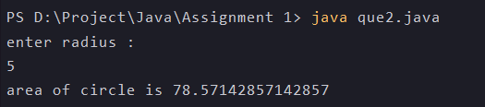

3)

import java.util.Scanner;  
class que3{  
 public static void main(String args[])  
 {  
 System.out.println("enter any two number :");  
 Scanner s=new Scanner(System.in);  
 double num1=s.nextDouble();  
 double num2=s.nextDouble();  
 if(num1>num2)  
 System.out.println(num1 +"is greater than "+num2);  
 else  
 System.out.println(num2 +"is greater than "+num1);  
   
 }  
   
}

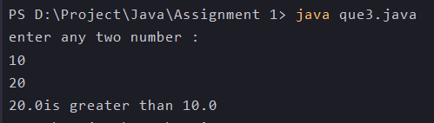

4)

import java.util.Scanner;  
class que4{  
 public static void main(String args[])  
 {  
 Scanner s=new Scanner(System.in);  
 System.out.println("enter any one number :");  
 double num1=s.nextDouble();  
 if(num1%2==0)  
 System.out.println(num1 +"is even number");  
 else  
 System.out.println(num1 +"is odd number");  
 }  
}



5)

import java.util.Scanner;  
class que5{  
 public static void main(String args[])  
 {  
 Scanner s=new Scanner(System.in);  
 System.out.println("enter value of a:");  
 int a=s.nextInt();  
 System.out.println("enter value of b:");  
   
 //swaping using third variable  
 int b=s.nextInt();  
 int c=a;  
 a=b;  
 b=c;  
 System.out.println("after swapping : a="+ a +" and b="+ b);  
   
 //swapping without third variable  
 System.out.println("enter value of a:");  
 int a1=s.nextInt();  
 System.out.println("enter value of b:");  
 int b1=s.nextInt();  
 a1=a1+b1;  
 b1=a1-b1;  
 a1=a1-b1;  
 System.out.println("after swapping : a="+ a1 +" and b="+ b1);  
   
   
 }  
}

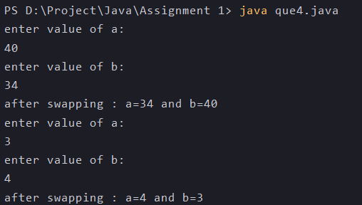

6)

import java.util.Scanner;  
class que6{  
 public static void main(String args[])  
 {  
 int a,fact=1,i;  
 System.out.print("enter number :");  
 Scanner s=new Scanner(System.in);  
 a=s.nextInt();  
 for(i=1;i<=a;i++)  
 {  
 fact=fact\*i;  
 }  
 System.out.println("factorial of "+ a + " is "+ fact);  
 }  
}



7)

import java.util.Scanner;  
class que7{  
 public static void main(String args[])  
 {  
 int a,i,ans;  
 System.out.print("enter number with which you want to multiplicate table:");  
 Scanner s=new Scanner(System.in);  
 a=s.nextInt();  
 for(i=1;i<=10;i++)  
 {  
 ans=a\*i;  
 System.out.print(ans+",");  
 }  
 }  
}



8)

import java.util.Scanner;  
class que8{  
 public static void main(String args[])  
 {  
 Scanner s=new Scanner(System.in);  
 System.out.println("enter one year :");  
 int yr=s.nextInt();  
 if(yr%4==0)  
 System.out.println(yr +" is leap year");  
 else  
 System.out.println(yr +" is not leap year");  
 }  
}



9)

class que9   
{   
 public static void main(String[] args)   
 {   
 int number = 987654, reverse = 0;   
 while(number != 0)   
 {   
 int remainder = number % 10;   
 reverse = reverse \* 10 + remainder;   
 number = number/10;   
 }   
 System.out.println("The reverse of the given number is: " + reverse);   
 }   
}



10)

import java.lang.\*;  
import java.io.\*;  
import java.util.\*;  
  
  
class que10{  
 public static void main(String[] args)  
 {  
 String input = "hardik";  
  
 char[] try1 = input.toCharArray();  
  
 for (int i = try1.length - 1; i >= 0; i--)  
 System.out.print(try1[i]);  
 }  
}

